Open Program Proposal

Thomas van der Molen

S4-AI41

Because I already have my learning outcomes on a Proficient, I will be attempting to use my open program to get all my learning outcomes to an advanced level.

During my open program I want to focus on approaching new machine learning techniques and integrating a more real-world implementation.

During this semester I have focused on using labeled data with supervised modelling methods, during open program I would like to try an unsupervised model. I think unsupervised modelling has a lot of real-world applications, just look at the recommendation feeds of; Netflix, YouTube, Amazon, etc. These all make use of unsupervised modelling techniques.

In my challenge I will be trying to create an unsupervised clustering customer recommendation model (like the ones found on e-shops as bol.com or amazon).

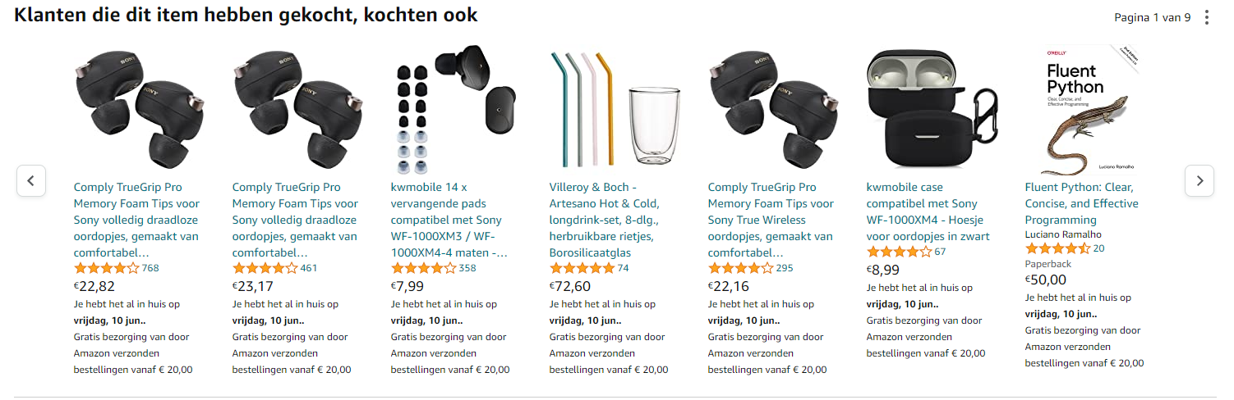

Getting customer data from an online store is not as easy because of company policies and the general value of this data. For this challenge I found a dataset on [Kaggle](https://www.kaggle.com/datasets/carrie1/ecommerce-data) that contains ~25000 real world records from an online wholesale e-commerce company.

I will be using this data in combination with an unsupervised clustering model to create customer recommendations.